DBT Self-Learning –SubQueries

- Employees Earning More Than Their Managers https://leetcode.com/problems/employees-earning-more-than-their-managers/

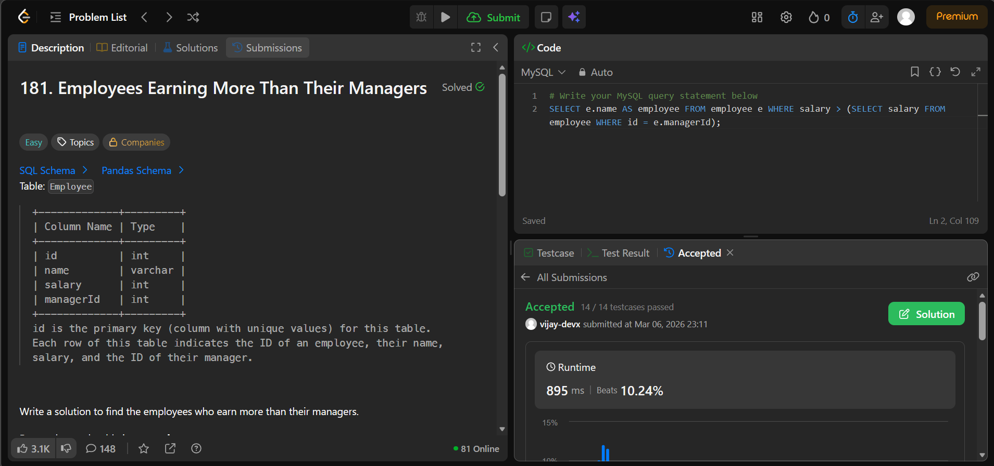

- Customers Who Never Order https://leetcode.com/problems/customers-who-never-order/
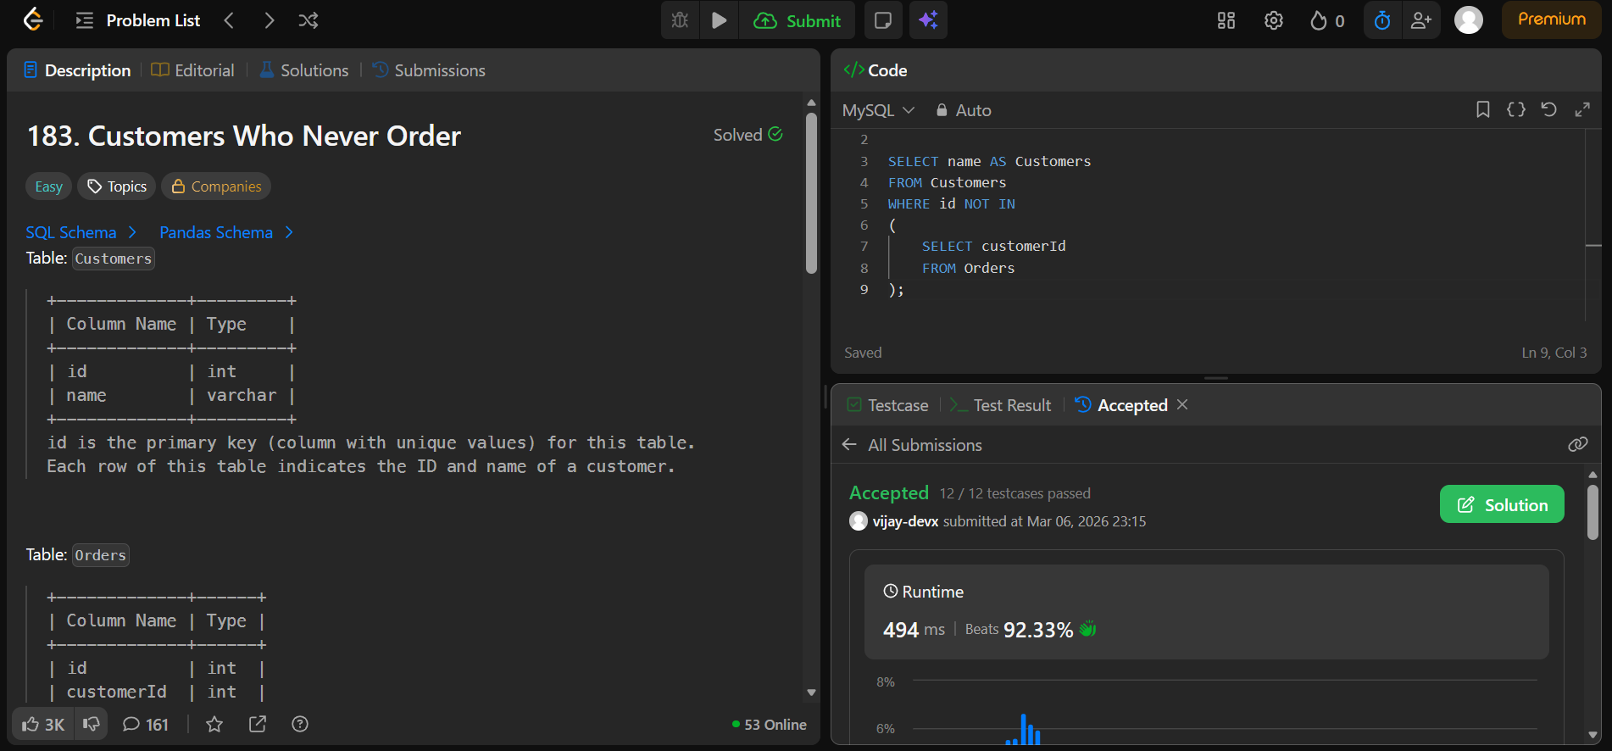

- Rising Temperature https://leetcode.com/problems/rising-temperature/

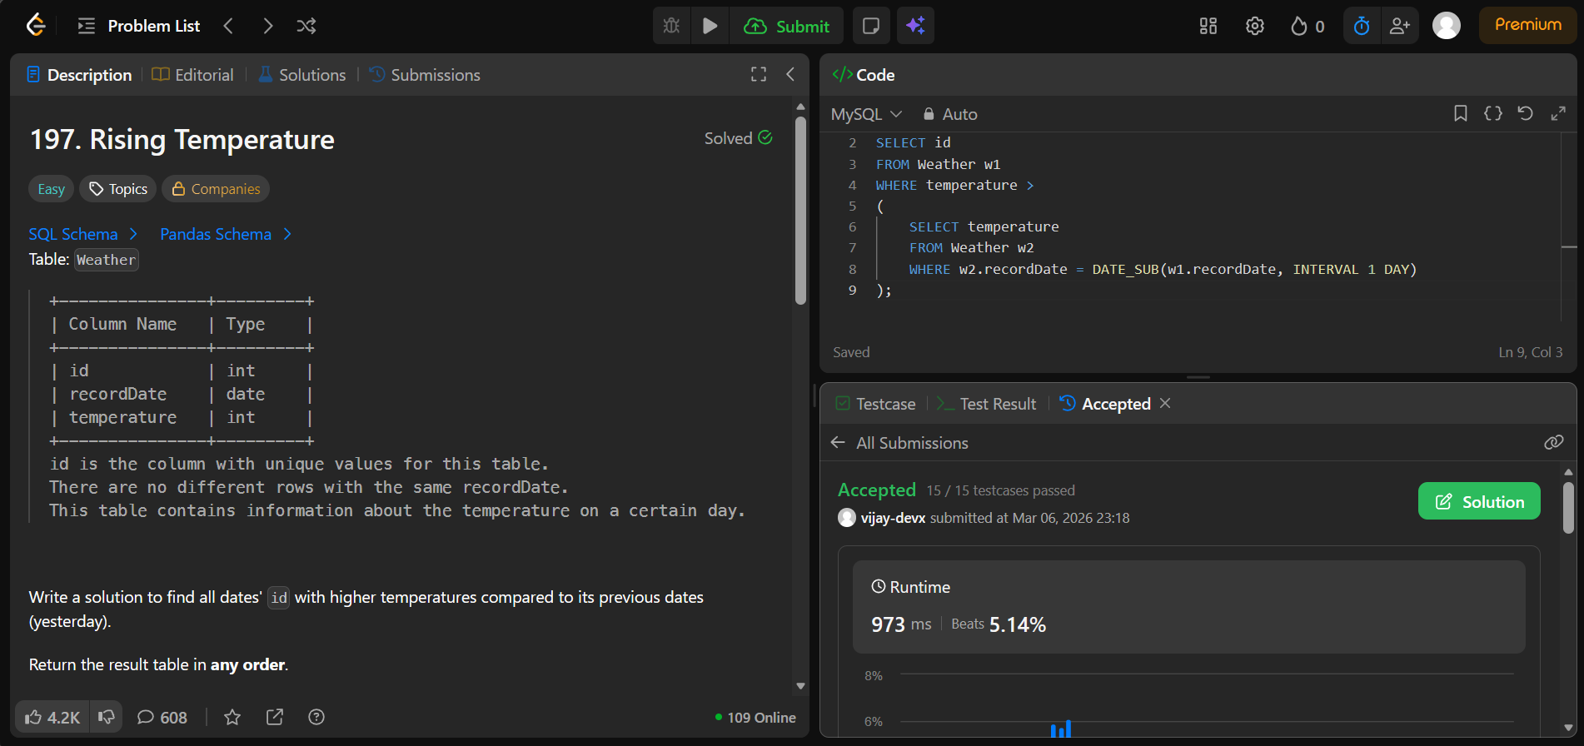

- Sales Person https://leetcode.com/problems/sales-person

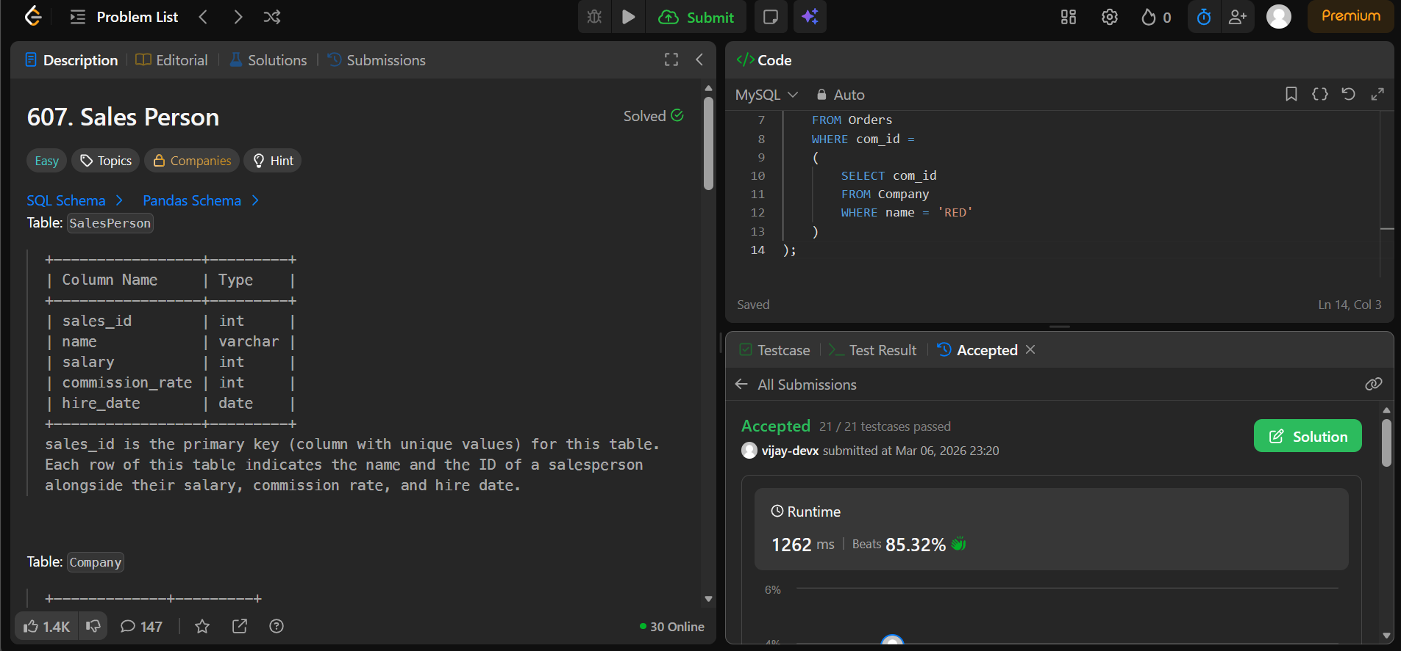

- Consecutive Numbers https://leetcode.com/problems/consecutive-numbers/
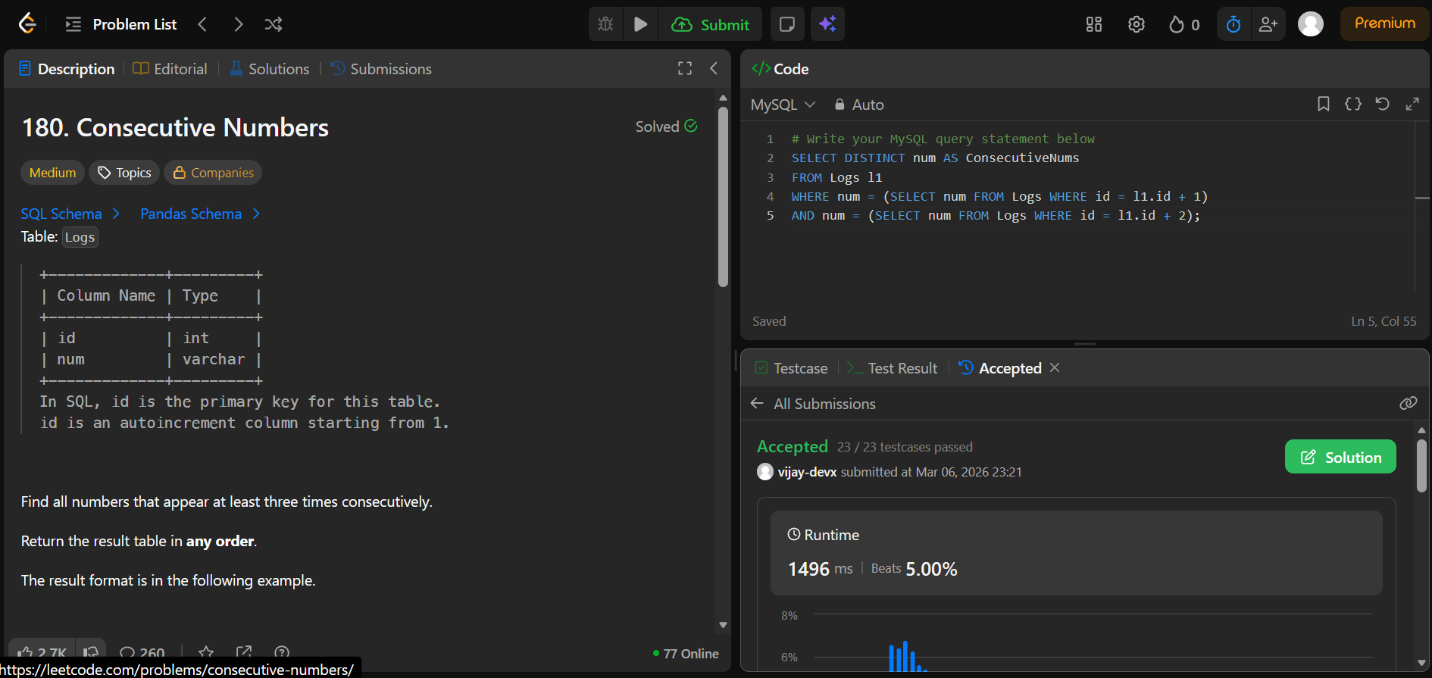

- Combine Two Tables https://leetcode.com/problems/combine-two-tables/

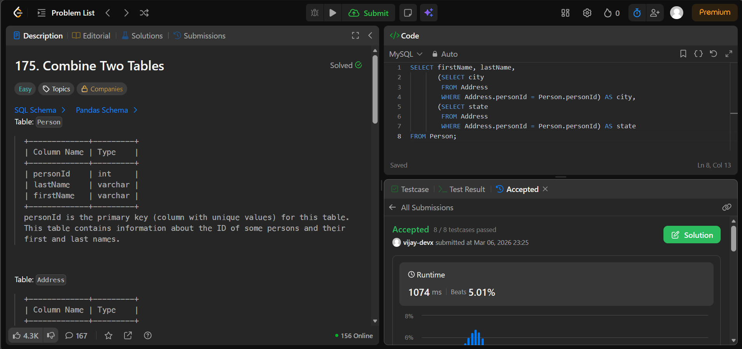

- Rank Scores https://leetcode.com/problems/rank-scores/

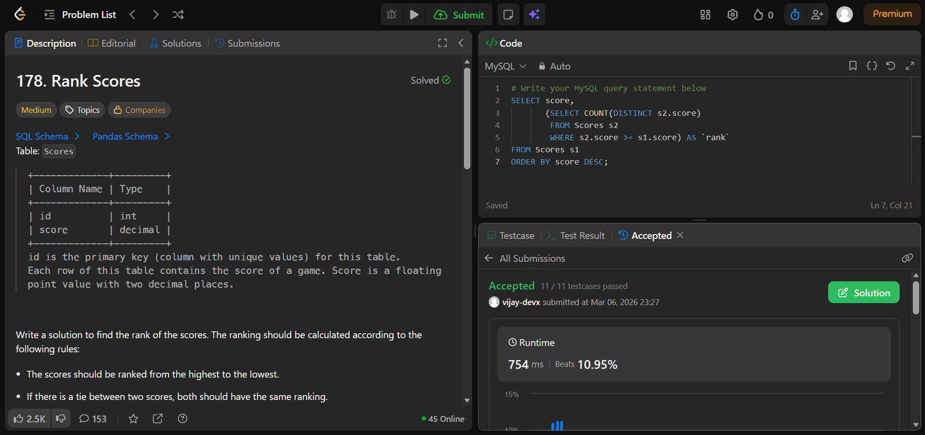

- Managers with at Least 5 Direct Reports https://leetcode.com/problems/managers-with-at-least-5-direct-reports

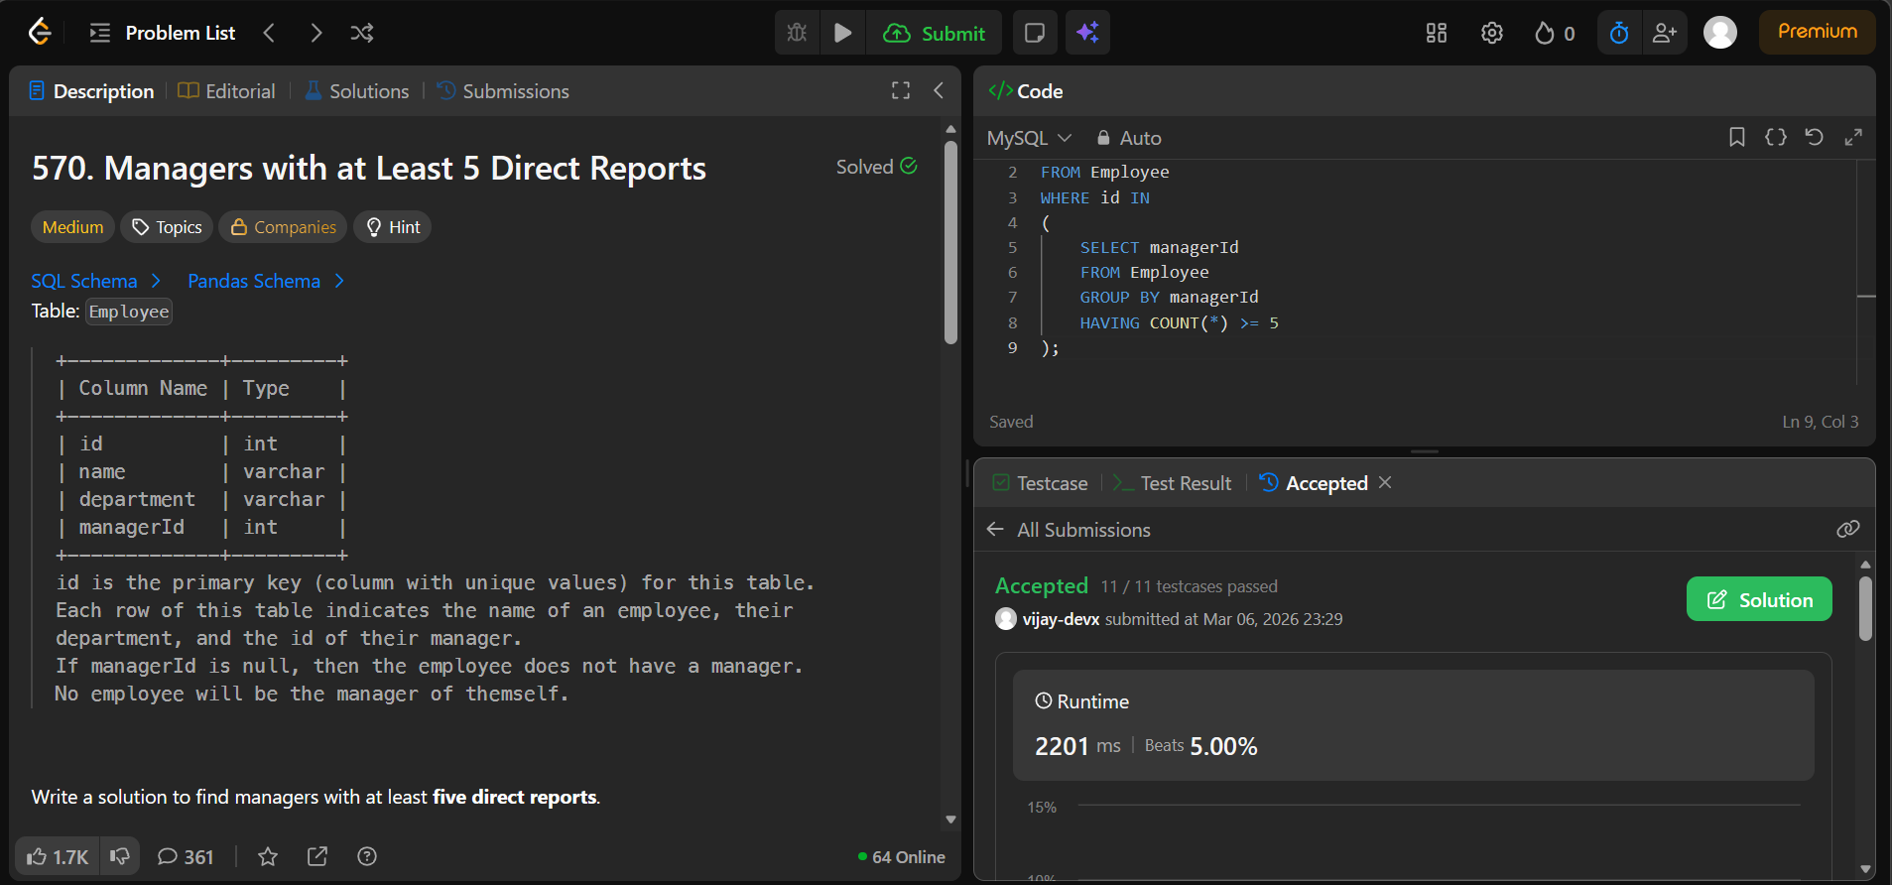

- Delete Duplicate Emails https://leetcode.com/problems/delete-duplicate-emails/

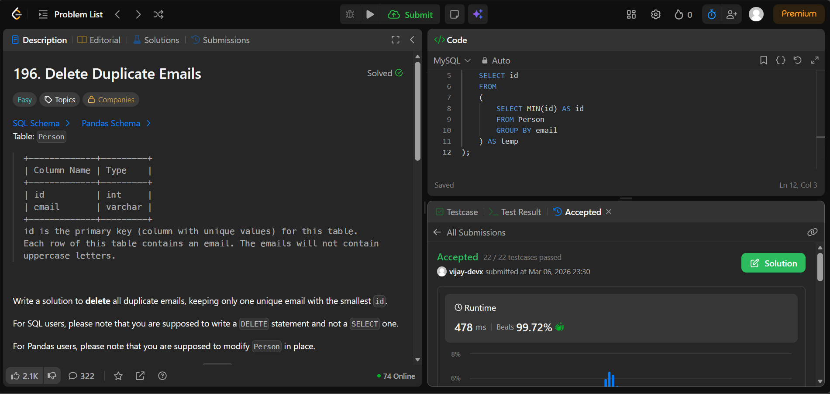

- Last Person to Fit in the Bus https://leetcode.com/problems/last-person-to-fit-in-the-bus/

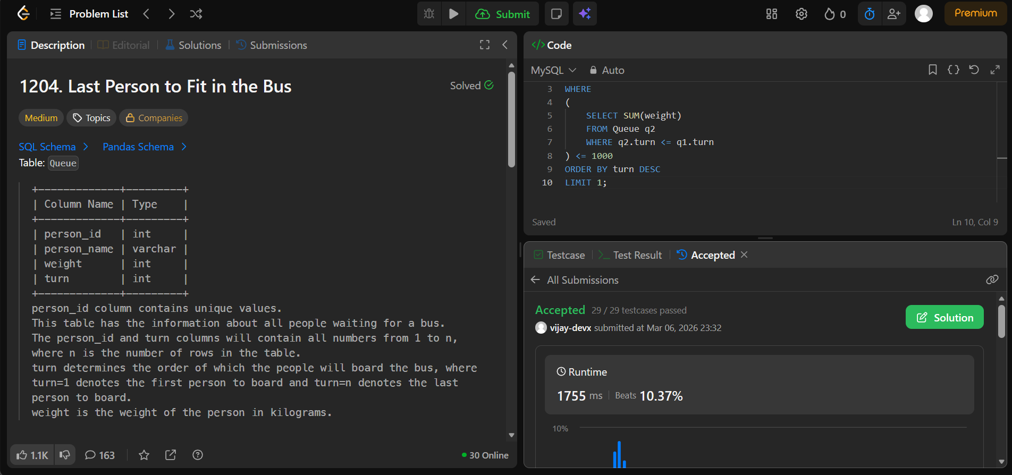

- Second Highest Salary https://leetcode.com/problems/second-highest-salary

